**Stage 2**

2024/25

Port of Tilbury

V5. TA 15/07/2024

Contractor Questionnaire

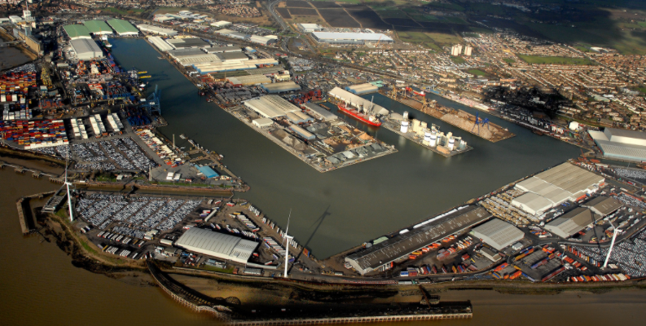



**Contractor Questionnaire**

**Section 1 – To be completed by Port of Tilbury**

**Contractor: ______________________________________________**

**Date: ____/____/____**

**Interviewer/auditor(s) ______________________________________________**

**Section 2**

Contractor to complete with as much information as possible. Please do not answer with just a yes or no response as this will affect your overall score which could impact your ability to be an approved contractor with the Port.

1. **If your appointment requires your organisation and it’s sub-contractors to provide Construction, Design and Management (CDM) expertise & experience can you demonstrate yours and your employees have sufficient knowledge of the CDM2015 Regulations and how would you evidence this.**

|  |
| --- |
|  |

**Actions:**

|  |
| --- |
|  |

**Score: ______**

1. **Describe your understanding of the Port’s security responsibilities particularly in reference to ISPS and AEO?** If you are unsure, please use additional resources such as the internet.

|  |
| --- |
|  |

**Actions:**

|  |
| --- |
|  |

**Score: ______**

1. **In an emergency or to report any suspicious activity, are you aware not to dial 999 for the Port Police?**

|  |
| --- |
|  |

**Actions:**

|  |
| --- |
|  |

**Score: ______**

1. **What is your understanding of the Port’s signing-in process centrally and in operational areas? What is the procedure if you wish to work in the Port of a weekend?**

|  |
| --- |
|  |

**Actions:**

|  |
| --- |
|  |

**Score: ______**

1. **Do you have access to a Safety Advisor either in-house or consultative? If yes to either please demonstrate their experience and competency. If no, do you have NEBOSH qualifications?**

|  |
| --- |
|  |

**Actions:**

|  |
| --- |
|  |

**Score: ______**

1. **Are all of your employees and sub-contractors attending the Port of Tilbury trained and competent in the work they are undertaking?** For example are your employee’s skills and capabilities kept to up to date and in line with current safety standards and regulations? Do they attend regular training?

**Actions:**

**Score: _______**

1. **Do you have a lone working policy?** Should you not have a policy, can you confirm that your job does not permit lone working. Equally, if you do not have a policy in place but your works could require it, can you explain below how lone working would be managed?

|  |
| --- |
|  |

**Actions:**

|  |
| --- |
|  |

**Score: ______**

1. **What levels of PPE are your employees and sub-contractors issued with? Are regular checks made to ensure the equipment is fit for the task/purpose? If you have lifejackets and harnesses do you inspect them regularly?**

|  |
| --- |
|  |

**Actions:**

|  |
| --- |
|  |

**Score: ______**

1. **We may, from time to time, audit your organisation to include employee competency, employee work visas, and company policies and so on. Have you any objections to this?**

|  |
| --- |
|  |

**Actions:**

|  |
| --- |
|  |

**Score: ______**

1. **Are you a member of the Construction Skills Certification Scheme? If not are you prepared to become one** (if not you will need to take the Port’s Praxis H&S E-Learning Module).

|  |
| --- |
|  |

**Actions:**

|  |
| --- |
|  |

**Score: ______**

1. **Can you demonstrate your knowledge of the Port’s geography and where operational areas are?** If not, please refer to the Forth Ports website for additional information.

|  |
| --- |
|  |

**Actions:**

|  |
| --- |
|  |

**Score: ______**

1. **Have you read and understood the document “Safety Rules for Contractors and Sub-Contractors on Port of Tilbury premises” and has this been passed down to your employees and sub-contractors working on Port premises?**

|  |
| --- |
|  |

**Actions:**

|  |
| --- |
|  |

**Score: ______**

1. **a) Have you watched the individual QR code videos contained within the lifesaving document? Can you confirm these will be shared with those persons attending site?**

**b) Can you confirm that you will share details of the health and safety QR code to report any safety observations to all persons attending site.**

**Actions**

**Score: ______**

1. **What is your understanding of inductions?** Can you define their purpose?

|  |
| --- |
|  |

**Actions:**

|  |
| --- |
|  |

**Score: ______**

1. **Does your organisation have a Modern Slavery Policy and/or statement?**

It is understood that currently under the Modern Slavery Act 2015 companies with a turnover of less than £36m p/a are not required to provide this, however PoTLL does and as such requires all of its contractors and suppliers as a minimum have an understanding of the Act. In this situation can you please provide evidence of your understanding and what your approach to the Act is?

|  |
| --- |
|  |

**Actions:**

|  |
| --- |
|  |

**Score: ______**

1. **How does your organisation interact and ensure compliance to current UK law and regulations throughout your supply chain, in particular tier 2 suppliers?**

**Actions:**

**Score: ______**

1. **Does your organisation have a GDPR policy and what is your understanding of it?** Should you not have a policy in place please complete the acceptance form.

|  |
| --- |
|  |

**Actions:**

|  |
| --- |
|  |

**Score: ______**

1. **Does your organisation have an Energy Policy and /or Statement?** Should you not have a policy or statement in place, can you confirm your agreement to the Port’s? We also need you to provide a roadmap of the ways in which you will consider energy management in the future, for example, low energy lighting.

|  |
| --- |
|  |

**Actions:**

|  |
| --- |
|  |

**Score: ______**

1. **Does your organisation have an Environment and Sustainability Policy?** Should you not have a policy in place please complete the acceptance form.

|  |
| --- |
|  |

**Actions:**

|  |
| --- |
|  |

**Score: ______**

1. **Do you confirm acceptance to abide by the Port of Tilbury Policies and Procedures for any policies and procedures that your organisation does not hold and that are required by the Port.**

**These are:**

Alcohol and Substance Misuse Policy Energy, Environment and Sustainability

Smoking Policy Safety Guidelines for Contractors

Business Ethnics and Conduct Policy Data Protection - GDPR

Mobile Device Policy

Security Policy

Please refer to Port of Tilbury Policies and Procedures Guide for additional information.

|  |
| --- |
|  |

**Actions:**

|  |
| --- |
|  |

**Score: ______**

**Section 3 – To be completed by Port of Tilbury**

Overall Score:

|  |  |  |  |
| --- | --- | --- | --- |
| **Scoring Mechanism per question** | **Status** | **Total Score** | **Action if Required/Notes** |
| **0-6** | **Fail – Non Approved** |  |  |
| **7-10** | **Pass** |  |  |

Overall Score __________ Approved / Not Approved Date: _____/____/_____